Dated 23.05.2024

Global accelerator Lab

Difference between cloud front and Global accelerator .

**Hands on Global Accelerator**

1 - Launch a EC2 in one of the region and install Tomcat Apache (Frankfurt - eu-central-1)

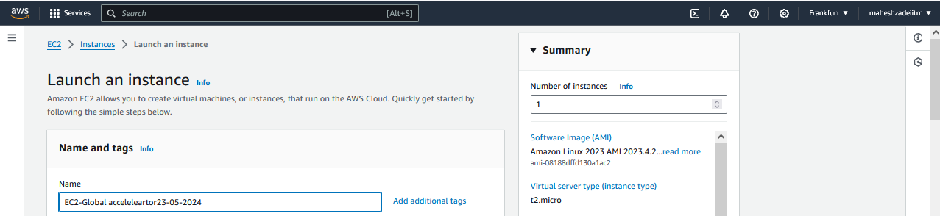

Amazon Linux 2

Choose the keypair

Choose default VPC Public Subnet and enale public IP

Create a SG for Global accelerator

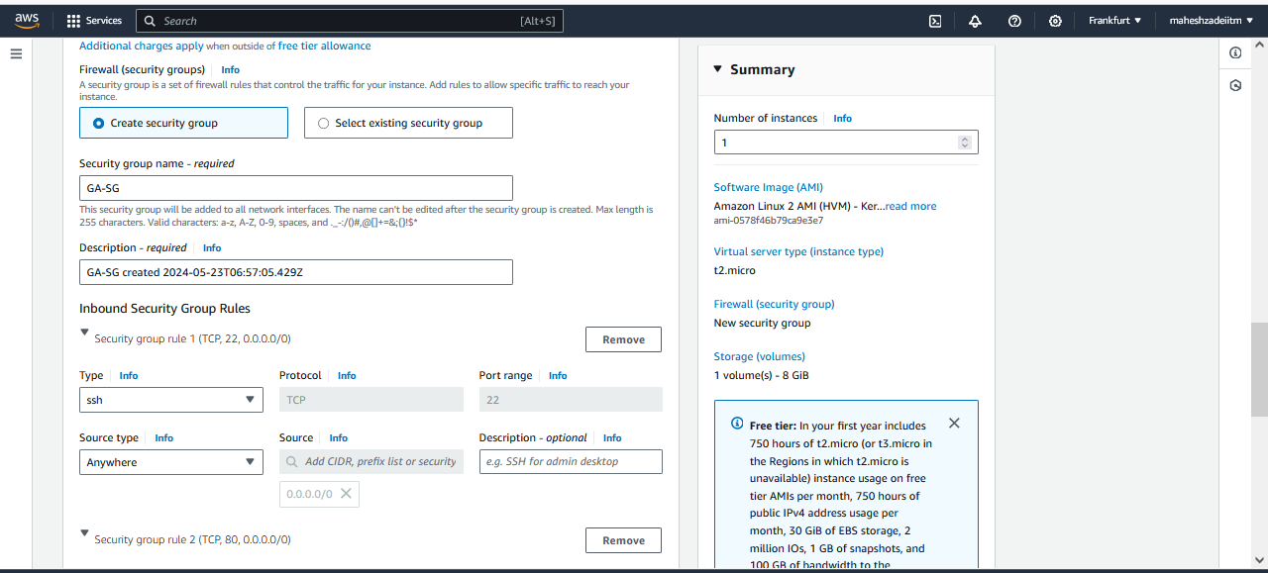

Add http protocol>> Anywhere

update below commands at the user data, check your region and region code

#!/bin/bash

yum update -y

yum install httpd -y

systemctl start httpd

systemctl enable httpd

echo "<h1>Hello from $(hostname -f)</h1> from Us-west-1" > var/www/html/index.html

Launched EC2

2 - Launch second EC2 in one another region and install Tomcat Apache (London - EU-West-2)

Folow the same steps for London -EU-west-2 region

Amazon Linux 2

Choose Public Subnet

Add http protocol>> Anywhere

update below commands at the user data, check your region and region code

#!/bin/bash

yum update -y

yum install httpd -y

systemctl start httpd

systemctl enable httpd

echo "<h1>Hello from $(hostname -f)</h1> from eu-west-2" > var/www/html/index.html

3 - Check if your apache is up and running or not (Individually) in both the regions

Copy the public IP of the both EC2 instances from Frankfurt and London region and check

Test from Frankfurt

Test from London

Test and apache is working.

4 - Launch Global Accelerator (GLobal Service) and attach your endpoints and Listener rules

Go to AWS Console and select the Global accelerator.

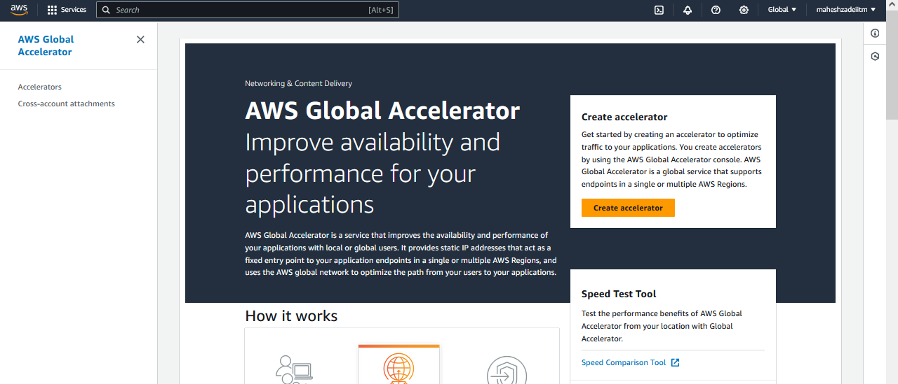

Create accelerator

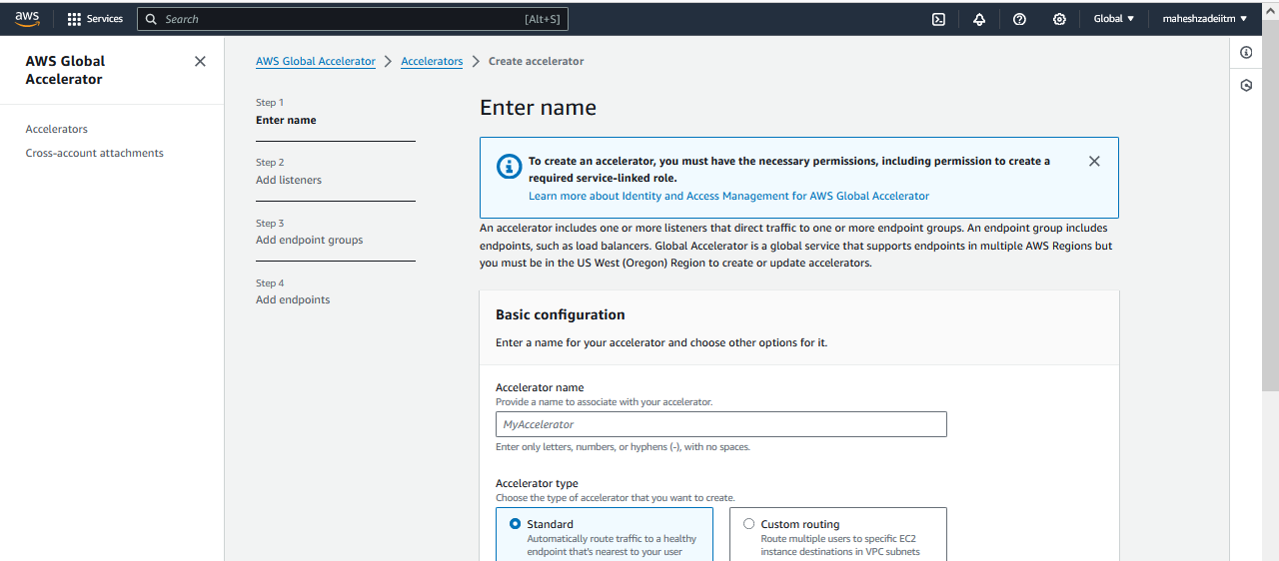

Accelerator name >>>> MYGA-23-05-2024

Accelerator type - Standard

IP address type >>> IPv4

Next

Add Listener -

Ports - 80,

Protocol - TCP

Client affinity >>> None

Next

Add endpoint groups

Endpoint group 1

Region >>> Choose your First Region

Traffic dial >>>> 100

Configure health checks

Health check port >>> 80

Health check protocol >>> HTTP

Health check path >>>> /

Health check interval >>> 10

Threshold count >>>> 3

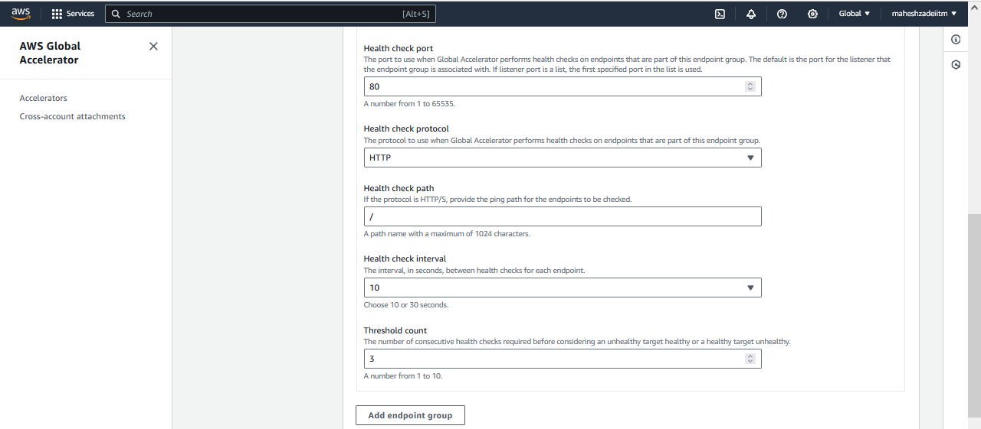

Repeat >>> Add endpoint groups for your second region

Endpoint group 2

Region >>> Choose your Second Region

Traffic dial >>>> 100

Configure health checks

Health check port >>> 80

Health check protocol >>> HTTP

Health check path >>>> /

Health check interval >>> 10

Threshold count >>>> 3

Next

Once it is successfully loaded

Add endpoints

Endpoint 1

Endpoint type - EC2

Endpoint - your EC2 ID

""And repeat for another region as well ""

5 - Test your Global Accelerator is working

- Copy your DNS name and try to access your website

Copy DNS and paste in browser

a3c7abb8c46cea0b1.awsglobalaccelerator.com

# Make a note of that result >> for example - **Hello from ip-172-31-29-159.eu-west-2.compute.internal**

from eu-west-2

Go that EC2 and remove that inbound rule from that associated SG and see what is the result

(or) stop that server.

Lond DC EC2 is ON and Frnafurt DC EC2 in OFF

Now Frankfurt DC EC2 in ON and London Dc EC2 is OFF

Now Check the DNS of Global accelaerator

DNS of GA : a3c7abb8c46cea0b1.awsglobalaccelerator.com

# compare both of them >> Hello from ip-172-31-22-0.eu-central-1.compute.internal

from Us-west-1

If you see that is switched to another region, then your global Accelerator is working

Now My global Accelerator is working fine .

Pls Check and Confirm .

Thanks